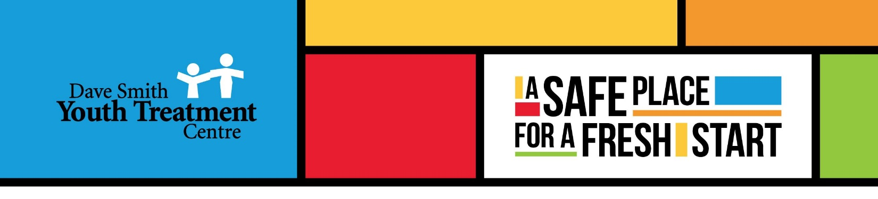

Overnight Support
Part time and Casual, Relief positions available
Dave Smith Youth Treatment Centre

Job Categories: | Youth Worker
Position Type: | Part time
Job Region: | Carleton Place & Carp

Are you interested in helping adolescents and their families overcome addiction and mental health problems as part of a Centre of Excellence?
The Dave Smith Youth Treatment Centre (DSYTC) is a non-profit, residential and community-based agency that is dedicated to helping youth (13-21) and families across Ontario overcome substance use and mental health issues to achieve a healthier lifestyle. DSYTC delivers evidence-based residential programming from 2 locations; Carleton Place and Carp.
The Overnight Support position is responsible for the safety and support of clients, security of the building and property during the fully awake shift. The part time positions are available at our Carp and Carleton Place residence. Hours of work are Monday through Sunday, 11:00 pm to 7:00 am.
Main Responsibilities (Non-Exhaustive List):
- Ensure the safety and security of clients, staff and physical residence during overnight shifts.
- Complete the prescribed nightly schedule of responsibilities, including fire safety, security and related documentation.
- Respond to emergency or crisis situations according to procedures.
- Implement aspects of the client's plan of care and therapeutic activities applicable to the shift.
- Support meal preparation, housekeeping, preventive maintenance and clerical duties.
- Complete documentation each shift to agency and ministry standards
- Inform superiors and document exceptional circumstances associated with clients and/or the building and resources.

Competencies:
- Client service orientation
- Teamwork and cooperation
- Ethical conduct and professionalism
- Attention to detail
- Effective communication skills
Education, Experience, Licenses and Certificates:
- High School Diploma. Post-secondary education in Child & Youth Care or Social Services desired.
- Employment or volunteer experience with young adults.
- Ability to work effectively in an automated office environment, including the use of various software such as electronic mail, word processing, spreadsheet, database.
- Valid Class ‘G’ driver’s license and use of a vehicle (our facilities are not serviced by public transportation)
- First Aid and CPR training
- Ability to obtain a valid Police Records Check for Service with the Vulnerable Sector
Hourly Rate: $20.12
Company Profile
The Dave Smith Youth Treatment Centre (DSYTC) is a non-profit and community-based agency that is dedicated to helping youth (13-21) and families across Ontario overcome substance use and mental health issues to achieve a healthier lifestyle. DSYTC delivers evidence-based, live-in programming from 2 locations; Carleton Place & Carp.
We offer a competitive remuneration package, opportunities for personal and professional growth in a supportive environment.
Should the applicant require any accommodations during the application or interview process, please notify Human Resources in advance at hr@davesmithcentre.org as per the Accessibility for Ontarians with Disabilities Act. As an equal opportunity employer DSYTC seeks to recruit, develop and retain the most talented people from a diverse candidate pool. We celebrate diversity and are committed to creating an inclusive environment for all employees.
Please note that according to the DSYTC Vaccination Policy, all applicants must be fully vaccinated unless they can provide the proof of a valid medical contraindication or exemption on the basis of protected grounds under the Ontario Human Rights Code in order to be considered for any staff or volunteer opportunities. Upon hiring, applicants must provide the proof of either government issued documentation proving they have been fully vaccinated, or present supporting documentation of a valid medical contraindication or exemption under Ontario Human Rights Code.
To apply please email your resume in confidence to: hr@davesmithcentre.org
We sincerely thank all applicants for their interest. However, only those selected for an interview will be contacted.

